SYNERGY OF THE MEDIA TO INFLUENCE THE REVISION OF THE GBV LAW IN BURUNDI BY COCAFEM/GL IN COLLABORATION WITH ICGLR-RTF. 15th Dec 2022 at RTNB/ARB.
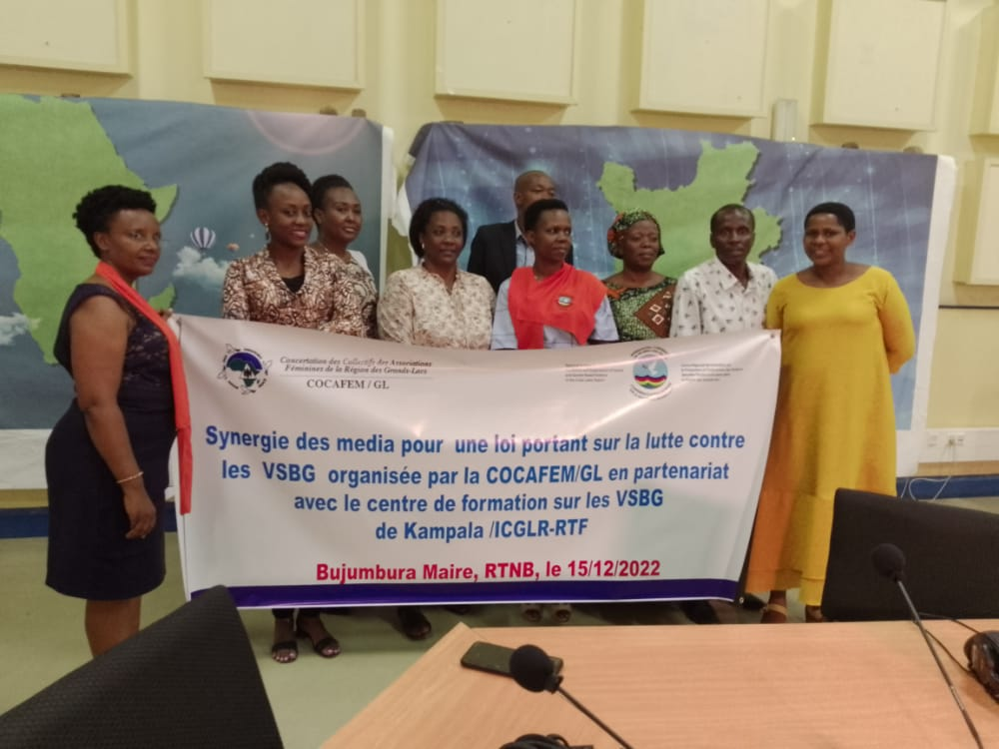
Participants for the Media Synergy include; ICGLR-RTF Regional Director, Rep from CARE Burundi ,Rep from Ministry of Gender, Rep from the Ministry of Justice, Rep from one stop Centre(Seruka), Association of Lawyers and Journalists.
The ICGLR-RTF in Collaboration with the COCAFEM/GL lauched a synergy of 9 local media, in order to influence positive changes on the Burundian law to Fight against Gender-Based Violence. This synergy was held within the Radio Television National Burundi /ARB premises on December 15th, 2022.
The collected interventions confirmed the need to revise the Burundian law on SGBV, as it still contains many gaps. In Preparation for the Media synergy , the ICGLR-RTF prepared a meeting on the dates of December 08th and 09th , 2022 respectively.
This meeting brought together officials from Burundi Judiciary, Ministry of Justice as well as the Ministry of Gender in its attributions and legal practcitioners in Burundi.
During the meeting all the officials recognised that there were still many elements missing and needed to be added in the Law to efectively protect Burundian women.
The meeting concluded that, the law is still incomplete with contradictions and still needs to be consolidated so that it serves the purpose of fighting SGBV.

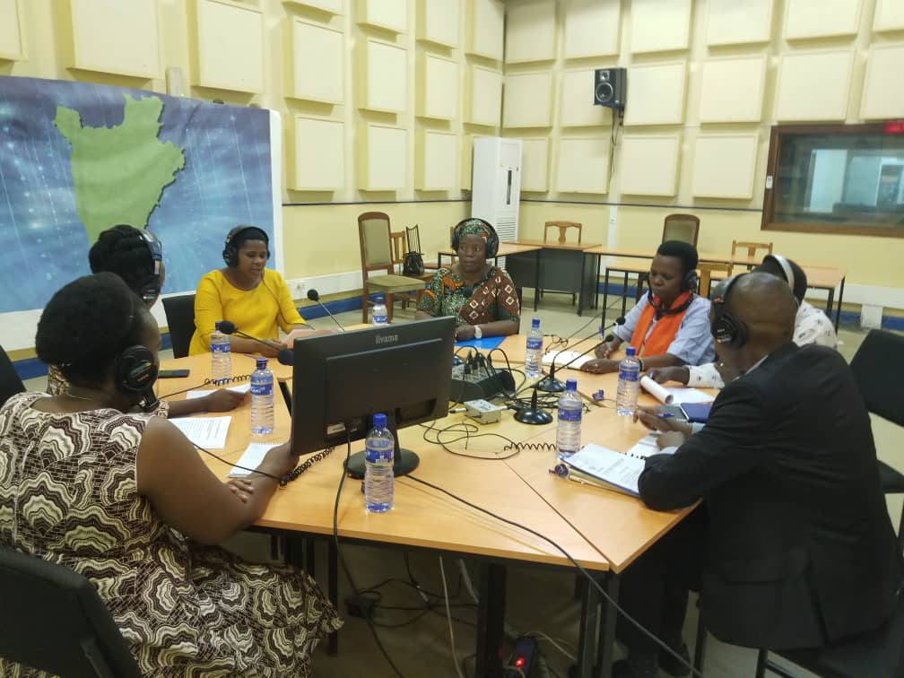
The participants during the Talk show on RTNB/ARB Premises

