Uganda National Launch of 16 Days of Activism under the theme: UNITE! Activism to End Violence Against Women and Girls in Kampala on 24th November 2022, led by Ministry of Gender, Labour, and Social Development. (MGLSD)

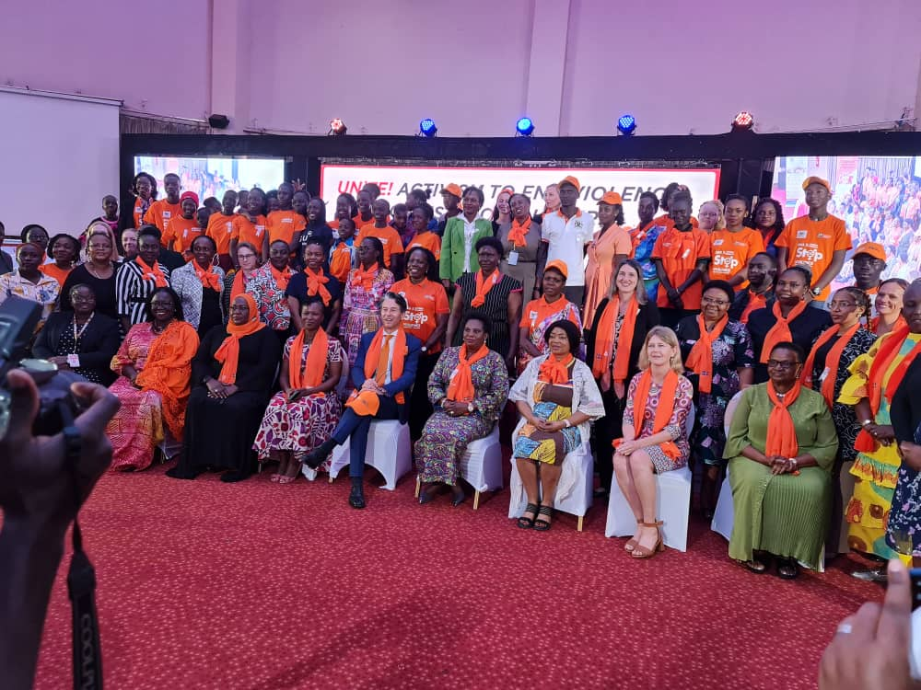
ICGLR-RTF Regional Director, UN Agency delegation, Minister of Gender Labour and Social Development, European Union and other Invited guests.

A Common goal aimed at bringing an end to Violence in Uganda was Launched in Kampala under 16 Days of Activism against Gender Based Violence Campaign whose theme was: "UNITE"! Activism to End Violence against Women and Girls.

The Ministry of Gender, Labour and Social Development (MGLSD), with support from UN Women Uganda; organised the National Launch in Kampala on 24th/November/2022; following its inception in 2021(16 Days of Activism 2021) basing on a report in which Uganda Police Force received 16,000 reports of sexual related offences- one report every 30 minutes.

The Participants were concerned that there was a continued prevalence of violence against women and girls; and the dire need to urgently work together towards ending all forms of violence against women.

This was evident from the remarks shared by Donors; the testimonies from the Community and the commitment to the cause shared by Government representatives through Videos that were played at the Launch; illustrating the work conducted in Uganda to support survivors of violence and efforts to prevent all forms of discrimination against women.

Among the Delegates was ICGLR-RTF Regional Director Hon Dr. Janviere Ndirahisha.

In their remarks the Ambassador of Sweden who spoke on behalf of the Development Partners and Donor Community in Uganda; shared recent statistics on teenage pregnancy.

While the Chairperson National Women's Council Faridah Kibowa and the Honourable Minister of Gender, Labour and Social Development; Betty Amongi reinforced with figures from Uganda Bureau of Statistics and emphasized the timely importance of this Campaign.

On the same occasion; Civil Society Organisation Frauen Initiative Uganda (supported by UN Women) held an exhibition entitled, "what I was wearing" from which Ministry of Gender, Labour and Social Development Permanent Secretary urged Participants and Ugandans at large not to 'agonise' but organise themselves when it comes to ending violence against women and girls.

The Launch was a Call to Action; where representation from United Nations Family; the Diplomatic Community and the Government highlighted the need for concerted efforts to take urgent action.

The Launch also left Participants asking, "What Can we Do?" to make the World safer for Women and Girls.

They therefore committed to continue working together to end violence in Uganda.

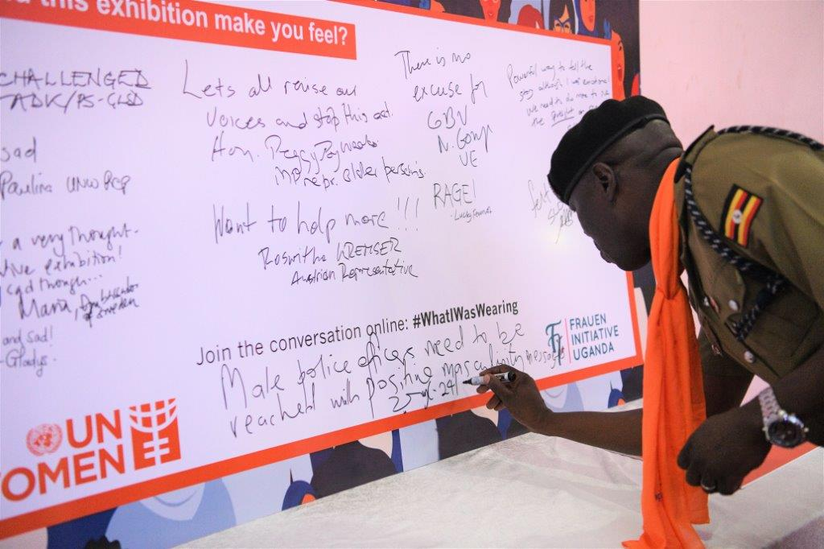
ICGLR-RTF National Trainer Police Officer Francis Ogweng shares feedback to the "What I Was Wearing" Exhibition at the National Launch.

